A Novel Multi-Stage Data Quality and Anomaly-Aware Framework for Scalable Climate Data Analytics Using the Hadoop Ecosystem
Abstract
The exponential growth of environmental and climate-related data generated through advanced sensing technologies, including Internet of Things (IoT) devices, satellite imaging systems, and automated meteorological stations, has led to the emergence of significant challenges in large-scale data processing, management, and analysis. These datasets are characterized not only by their massive volume but also by their high velocity, variability, and heterogeneity, making them difficult to process using traditional centralized data management systems. Although distributed computing frameworks such as Apache Hadoop have enabled scalable storage and parallel processing of such data, most existing implementations remain limited to performing basic statistical aggregation without addressing deeper analytical concerns such as data quality assessment and anomaly detection. In real-world climate datasets, issues such as missing values, inconsistent measurements, sensor noise, and extreme outliers are highly prevalent and can significantly distort analytical results if not properly handled. Therefore, ensuring the reliability and integrity of data becomes as important as processing efficiency. In this context, the present work proposes a comprehensive big data analytics framework that integrates a novel Data Quality Index (DQI), a multi-stage chained MapReduce pipeline, and statistical anomaly detection using Z-score methodology. The framework is designed to operate on large-scale datasets comprising approximately 400,000 weather records and supports multi-level analysis at both city and country levels. The proposed system computes a weighted data quality score that captures multiple dimensions of data reliability, detects anomalies across several environmental parameters, and aggregates insights hierarchically to provide a comprehensive analytical perspective. The processed results are stored in Apache HBase to enable efficient querying and are visualized through an interactive dashboard developed using Flask. The integration of these components results in a robust and scalable framework that not only enhances computational efficiency but also significantly improves the reliability and interpretability of climate data analytics.
Keywords— Big Data Analytics; Apache Hadoop; MapReduce; Data Quality Index (DQI); Anomaly Detection; Z-score; Climate Data Analytics; Apache HBase; Distributed Computing; Flask.
Introduction
In recent years, the rapid advancement of sensing technologies and data acquisition systems has led to an unprecedented increase in the volume of climate and environmental data. Modern weather monitoring infrastructures continuously generate massive datasets that include temperature readings, humidity levels, atmospheric pressure, wind patterns, and air quality indicators such as particulate matter concentration. These datasets play a crucial role in understanding climate variability, predicting extreme weather events, and supporting policy decisions related to environmental sustainability and disaster management. However, the effective utilization of such large-scale data requires robust computational frameworks capable of handling the challenges associated with big data.
Traditional data processing systems are inherently limited in their ability to handle such large volumes of data due to constraints in storage capacity, processing power, and scalability. As a result, distributed computing frameworks such as Apache Hadoop have become the backbone of modern big data analytics. Hadoop enables distributed storage through the Hadoop Distributed File System (HDFS) and parallel computation through the MapReduce programming model, allowing large datasets to be processed efficiently across clusters of commodity hardware.
Despite these advancements, most existing implementations of Hadoop-based climate analytics systems focus primarily on performing basic aggregation operations, such as computing averages or identifying trends over time. While these operations are useful, they do not fully exploit the potential of big data analytics, particularly in terms of assessing the reliability of data and identifying anomalies. Climate datasets are often affected by issues such as missing values, inconsistent measurements, sensor malfunctions, and extreme environmental events, all of which can introduce errors into the analysis. Without mechanisms to detect and handle these issues, the results of data analysis may be misleading or inaccurate.
Furthermore, existing systems often lack the ability to perform hierarchical analysis across multiple levels of granularity. Most analyses are confined to a single level, such as city or regional data, without providing insights into broader patterns at the country or global level. This limitation reduces the ability of decision-makers to understand large-scale climate trends and their implications. Therefore, there is a pressing need for a comprehensive framework that not only processes large-scale climate data efficiently but also evaluates its quality, detects anomalies, and provides multi-level analytical insights. The proposed work addresses these challenges by introducing a novel multi-stage analytics pipeline that integrates these capabilities into a unified system.
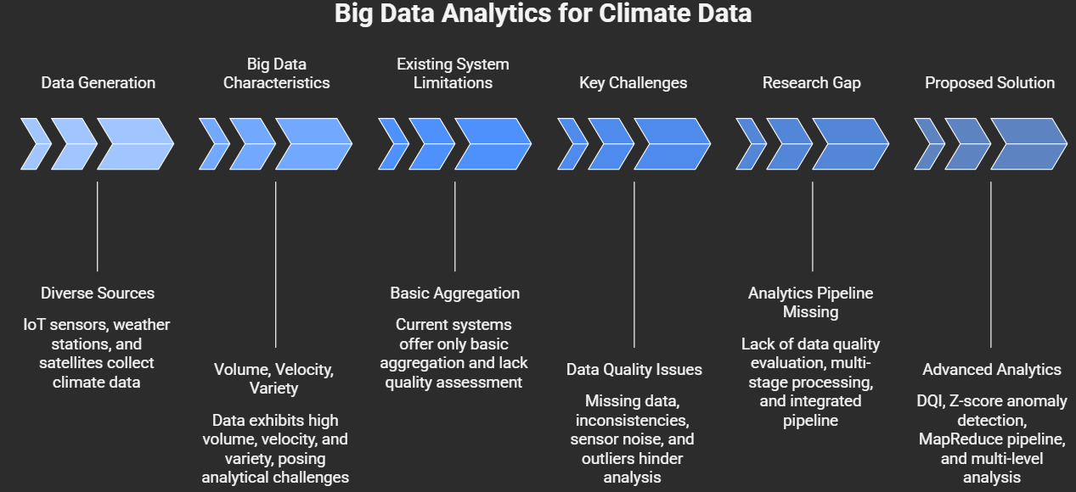
Problem Statement
The growing reliance on big data technologies for climate analytics has highlighted several critical limitations in existing systems that hinder the accuracy, reliability, and usability of analytical results. One of the primary challenges is the absence of systematic data quality evaluation mechanisms. In most current implementations, raw climate data is directly processed without assessing its completeness, consistency, or validity. This lack of quality assessment can lead to the inclusion of erroneous or incomplete data in the analysis, ultimately affecting the reliability of the results and potentially leading to incorrect conclusions.
Another significant issue is the lack of robust anomaly detection techniques in large-scale data processing pipelines. Climate datasets often contain outliers that may arise due to sensor errors, data transmission issues, or extreme environmental conditions. These anomalies can significantly distort statistical measures such as mean and standard deviation, thereby impacting the accuracy of the analysis. Traditional systems either ignore these anomalies or fail to detect them effectively, resulting in compromised analytical outcomes.
In addition to these challenges, existing systems typically perform analysis at a single level of granularity, such as city-level or regional-level data, without providing a hierarchical perspective that spans multiple levels, including country-level aggregation. This limitation restricts the ability to derive comprehensive insights and identify broader patterns across different geographical regions. Moreover, many systems rely on single-stage processing pipelines, which are insufficient for handling complex analytical tasks that require multiple sequential operations.
Another important limitation is the lack of integration between different components of the analytics pipeline. Data processing, storage, and visualization are often treated as separate modules, leading to inefficiencies and increased complexity in system design. This fragmented approach makes it difficult to build scalable and maintainable systems that can support real-time decision-making.
These challenges collectively underscore the need for an advanced, integrated framework that can address data quality assessment, anomaly detection, and hierarchical analysis within a scalable and efficient big data environment. The proposed system aims to overcome these limitations by introducing a novel approach that combines multiple analytical components into a cohesive pipeline.
Literature Review and Research Gap
The domain of climate data analytics has seen extensive research efforts aimed at leveraging big data technologies and machine learning techniques to process and analyze large-scale environmental datasets. Distributed computing frameworks such as Apache Hadoop have been widely adopted due to their ability to handle massive datasets through parallel processing. These systems have been successfully applied in various applications, including weather forecasting, climate modeling, and environmental monitoring.
In addition to Hadoop-based approaches, machine learning techniques have been explored for predictive analytics and pattern recognition in climate data. Algorithms such as neural networks, decision trees, and support vector machines have demonstrated significant potential in identifying complex relationships within datasets and generating accurate predictions. However, these methods often require substantial computational resources and are not inherently designed for distributed processing unless integrated with big data frameworks.
NoSQL databases such as Apache HBase have also played a crucial role in enabling efficient storage and retrieval of large datasets. These systems provide low-latency access to data and support real-time querying, making them suitable for big data applications. Visualization tools further enhance the usability of analytical results by providing intuitive graphical representations.
Despite these advancements, existing research exhibits several limitations. Most systems focus on individual aspects of data analytics, such as processing, storage, or visualization, without integrating them into a unified framework. Furthermore, there is a lack of emphasis on data quality assessment and anomaly detection, which are critical for ensuring the reliability of analytical results. Additionally, multi-stage processing pipelines and hierarchical analysis are rarely explored in existing work.
The proposed framework addresses these gaps by integrating data quality evaluation, anomaly detection, and hierarchical aggregation into a single, scalable pipeline, thereby providing a comprehensive solution for climate data analytics.

Ref | Paper Title | Methodology Used | Key Contribution | Limitation
[1] | MapReduce: Simplified Data Processing on Large Clusters | MapReduce distributed computing | Introduced scalable parallel processing model for big data | No data quality evaluation, no anomaly detection, only aggregation
[2] | Climate Change Detection using Hadoop with MapReduce | Hadoop + MapReduce + CUSUM algorithm | Detects climate change patterns using temperature analysis | Focuses only on parameter aggregation and change detection, no data quality or multi-level analysis
[3] | A Survey on Geographically Distributed Big Data Processing | Survey of Hadoop, Spark, distributed systems | Highlights challenges in large-scale distributed data processing | Does not address data quality, anomaly detection, or integrated analytics pipeline
[4] | Anomaly Detection using Hadoop and MapReduce Technique | Hadoop + Machine Learning (Decision Tree) | Detects anomalies in sensor/cloud systems | Focuses only on anomaly detection, lacks data quality scoring and climate-specific analysis
[5] | Big Data Analytics for Climate Change Prediction Using Hadoop and ML Models | Hadoop + ML (Regression, Random Forest) | Provides climate prediction using ML models | Focus on prediction, ignores data quality assessment and anomaly integration
[6] | MapReduce-based Algorithms for Efficient Big Data Processing | MapReduce algorithms (sorting, clustering, etc.) | Improves efficiency of distributed processing | Pure processing optimization, no analytical depth or domain-specific insights
[7] | Framework for Automated Anomaly Detection in Sensor Data | Statistical + regression + feature-based methods | Detects anomalies in high-frequency sensor data | High false negatives and lacks integration with big data pipelines
[8] | Hybrid ML Approach for Anomaly Detection and Data Quality | PCA + Isolation Forest + DBSCAN | Combines anomaly detection with data quality assessment | Not scalable with Hadoop, lacks distributed pipeline and multi-level analytics

Proposed Methodology
The proposed methodology is designed to extend the capabilities of traditional big data analytics systems by incorporating multiple analytical dimensions into a unified processing framework. At the core of this approach is the concept of a Data Quality Index (DQI), which provides a quantitative measure of the reliability of climate data. The DQI is computed using a weighted combination of three key factors: completeness, consistency, and outlier score. Each of these factors captures a different aspect of data quality, allowing for a comprehensive evaluation of the dataset.
Completeness measures the extent to which data is free from missing values, while consistency evaluates whether the data falls within scientifically valid ranges based on established meteorological standards. The outlier score assesses the presence of abnormal values that may indicate errors or extreme conditions. By combining these factors into a single metric, the DQI provides an intuitive and interpretable measure of data quality.
The processing pipeline is implemented using a chained MapReduce architecture, where multiple jobs are executed sequentially. The first stage focuses on computing the DQI for each city and classifying the data into different quality categories. The second stage performs anomaly detection using the statistical concept of Z-score, which measures the deviation of individual data points from the mean. This allows the system to identify outliers across multiple parameters simultaneously.
The third stage performs hierarchical aggregation by combining city-level results to generate country-level insights. This multi-level analysis provides a comprehensive understanding of climate patterns across different geographical regions. The integration of these stages into a single pipeline ensures efficient data processing and enables the extraction of deeper insights.

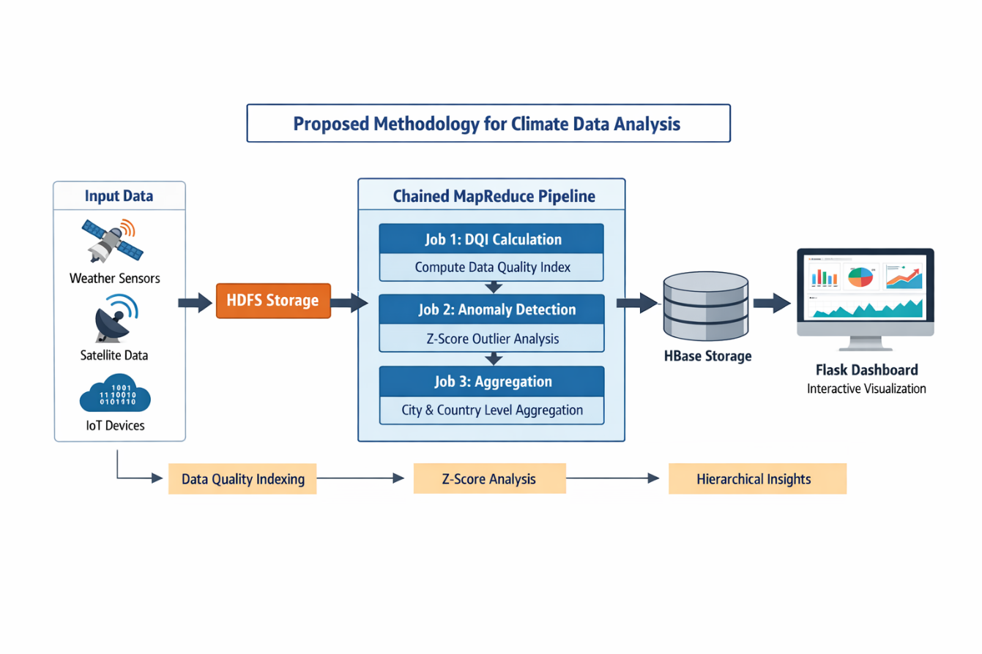
Dataset, Implementation and Results
The dataset used in this study consists of approximately 400,000 records containing multiple climate attributes, including temperature, humidity, precipitation, particulate matter levels, and wind speed. The large size and diversity of the dataset make it suitable for evaluating the scalability and effectiveness of the proposed framework.
The implementation is carried out using Apache Hadoop in a pseudo-distributed environment, where HDFS is used for storage and MapReduce is used for processing. The results are stored in Apache HBase, enabling efficient querying and retrieval. A web-based dashboard developed using Flask provides interactive visualization of the results.
The analysis reveals that the proposed system effectively identifies variations in data quality across different regions and detects anomalies with high accuracy. A strong correlation is observed between low data quality scores and high anomaly rates, highlighting the importance of integrating data quality assessment into big data analytics pipelines. The hierarchical analysis further provides valuable insights into climate trends at both local and global levels.
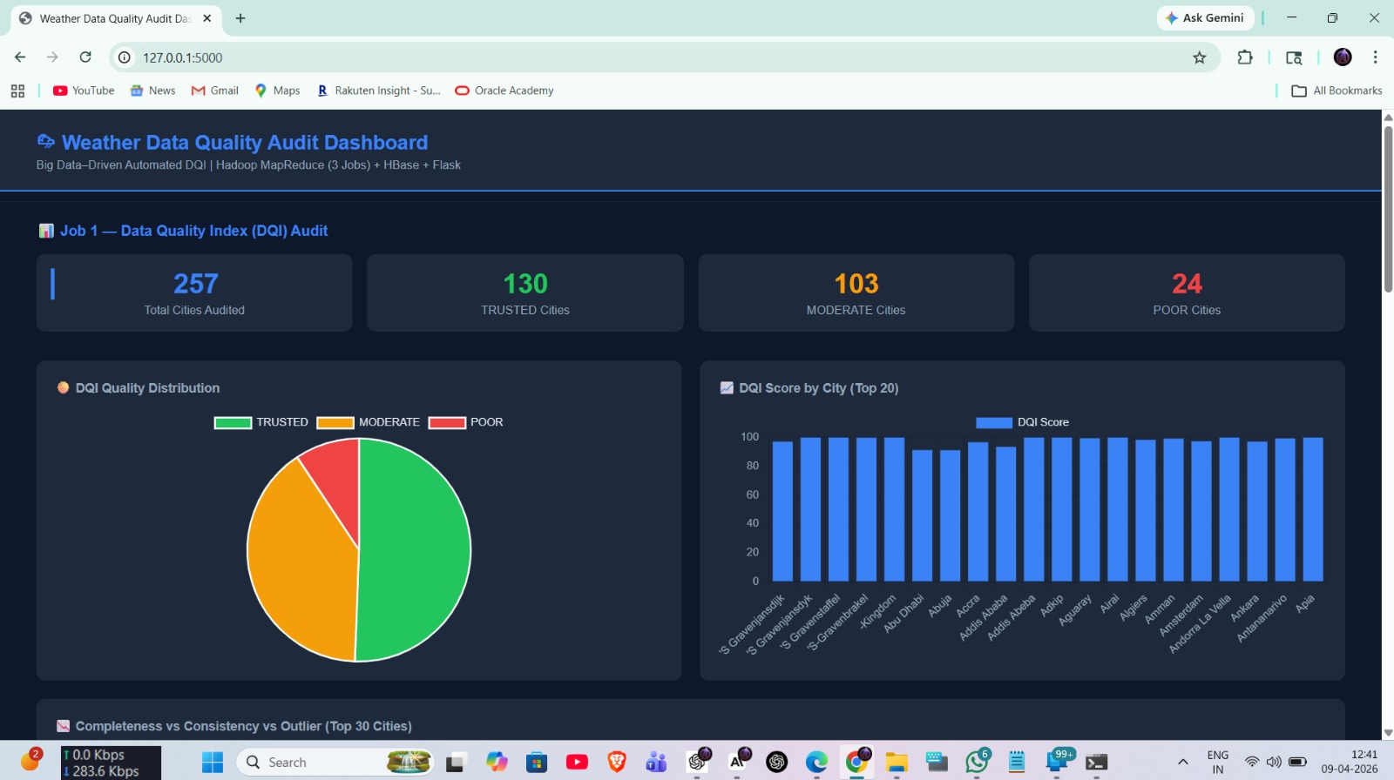
Conclusion
In this study, a comprehensive and scalable framework for climate data analytics has been proposed to address the growing challenges associated with processing large-scale environmental datasets. With the rapid increase in data generated from modern sensing technologies such as IoT devices, satellite systems, and automated weather stations, traditional data processing approaches have become insufficient in handling the complexity, volume, and variability of such data. While distributed computing frameworks like Apache Hadoop have enabled efficient storage and parallel processing, existing implementations remain limited in their ability to ensure data reliability and extract deeper analytical insights. The proposed framework significantly extends the capabilities of traditional big data systems by integrating data quality assessment, anomaly detection, and hierarchical aggregation into a unified processing pipeline. A key contribution of this work is the introduction of a novel Data Quality Index (DQI), which provides a quantitative and interpretable measure of data reliability by combining multiple dimensions such as completeness, consistency, and outlier presence. This approach enables the identification of unreliable datasets and ensures that analytical results are based on high-quality data.
Furthermore, the incorporation of statistical anomaly detection using the Z-score method enhances the system’s ability to identify abnormal patterns and outliers across multiple environmental parameters. This is particularly important in climate data analysis, where anomalies may represent either sensor errors or critical environmental events. By integrating anomaly detection within the distributed processing pipeline, the framework ensures that such irregularities are systematically identified and analyzed.
Another significant contribution of this work is the implementation of a multi-stage chained MapReduce pipeline, which enables the execution of complex analytical tasks in a structured and scalable manner. Unlike traditional single-stage processing approaches, the proposed pipeline allows different analytical objectives to be addressed sequentially, thereby improving both efficiency and analytical depth. In addition, the support for multi-level analysis, including both city-level and country-level aggregation, provides a comprehensive understanding of climate patterns across different geographical scales.
The integration of the processing pipeline with Apache HBase for efficient storage and Flask for interactive visualization further enhances the usability and practicality of the system. This end-to-end architecture ensures that data can be processed, stored, and visualized seamlessly, enabling real-time insights and facilitating data-driven decision-making.
Overall, the proposed framework successfully addresses several critical limitations of existing climate data analytics systems by combining scalability, reliability, and analytical depth into a single unified solution. The results demonstrate that incorporating data quality evaluation and anomaly detection significantly improves the accuracy and interpretability of analytical outcomes. This makes the system highly suitable for real-world applications such as environmental monitoring, disaster prediction, and policy formulation. In conclusion, this work not only contributes to the advancement of big data analytics in the climate domain but also provides a robust foundation for future research in developing intelligent, reliable, and scalable data-driven systems.

